**Name:** Sayli Bhor **Academic Year:** 2021-2022

**Class:** MSc CS Part I **Roll no.**: 48

**Subject:** Social Network Analysis

**Index**

|  |  |  |
| --- | --- | --- |
| **Sr. No.** | **Title** | **Page No.** |
| 1 | Write a program to compute the following for a given a network: number of edges, number of nodes, degree of node, node with lowest degree, the adjacency list, matrix of the graph. | 2 |
| 2 | Perform following tasks: View data collection forms and/or import onemode/two-mode datasets, Basic Networks matrices transformations | 11 |
| 3 | Compute the following node level measures: Density; Degree; Reciprocity; Transitivity; Centralization; Clustering. | 15 |
| 4 | For a given network find the following: Length of the shortest path from a given node to another node; the density of the graph; Draw egocentric network of node G with chosen configuration parameters. | 22 |
| 5 | Write a program to distinguish between a network as a matrix, a network as an edge list, and a network as a sociogram (or “network graph”) using 3 distinct networks representatives of each. | 29 |
| 6 | Write a program to exhibit structural equivalence, automatic equivalence, and regular equivalence from a network. | 33 |
| 7 | Perform SVD analysis of a network. | 38 |

# Practical 1

**Aim:** Write a program to compute the following for a given a network:

* number of edges
* number of nodes
* degree of node
* node with lowest degree
* the adjacency list
* matrix of the graph.

**Software(s) used:**

* R ver. 4.1.3
* RStudio ver. 2022.02.0+433

## External packages required:

* igraph

## Description:

* + **The** igraph **package:** igraph is a library and R package for network analysis.

The main goals of the igraph library is to provide a set of data types and functions for:

* + - pain-free implementation of graph algorithms,
    - fast handling of large graphs, with millions of vertices and edges, allowing rapid prototyping via high level languages

like R.

* + library()**:** library() loads and attach add-on packages.
  + graph.formula():
    - Creating (small) graphs via a simple interface
    - This function is useful if you want to create a small (named) graph quickly, it works for both directed and undirected

graphs.

* + plot(): Use to plot any graph.
  + ecount(): Returns the count of number of edges in graph
  + vcount(): Returns the count of number of vertices in graph
  + E():
    - Edges of a graph
    - An edge sequence is a vector containing numeric edge ids, with a special class attribute that allows custom operations:

selecting subsets of edges based on attributes, or graph structure, creating the intersection, union of edges, etc.

* + V():
    - Vertices of a graph
    - Create a vertex sequence (vs) containing all vertices of a graph.
  + degree():
    - Degree and degree distribution of the vertices
    - The degree of a vertex is its most basic structural property, the number of its adjacent edges.
    - Mode-Character string, “out” for out-degree, “in” for in- degree or “total” for the sum of the two. For undirected graphs this argument is ignored. “all” is a synonym of

“total”.

* + max() and min():
    - Maxima and Minima
    - Returns the (regular or parallel) maxima and minima of the input values.
  + get.adjacency(): Convert a graph to an adjacency matrix
  + get.adjlist():
    - Adjacency lists
    - Create adjacency lists from a graph, either for adjacent edges or for neighboring vertices

## Source Code:

library(igraph)

u_graph - graph.formula(A - B, A - C, A - D, B - C, B - F, C -

D, C - E, C - F, D - E, E - F, F - G, G - H)

d_graph - graph.formula(A + B, A + D, A -+ C, B -+ C, B -+ E, B -+ F, C -+ D, C -+ F, D -+ E)

e_count(u_graph) e_count(d_graph)

v_count(u_graph) v_count(d_graph)

E(u_graph) E(d_graph)

V(u_graph) V(d_graph)

degree(u_graph) degree(u_graph, mode = "in") degree(u_graph, mode = "out")

degree(d_graph) degree(d_graph, mode = "in") degree(d_graph, mode = "out")

V(u_graph)$name[degree(u_graph) = min(degree(u_graph))] V(d_graph)$name[degree(d_graph, mode = "in") = min(degree(d_graph, mode = "in"))] V(d_graph)$name[degree(d_graph, mode = "out") = min(degree(d_graph, mode = "out"))]

get.adjacency(u_graph) get.adjacency(d_graph)

get.adjlist(u_graph) get.adjlist(d_graph)

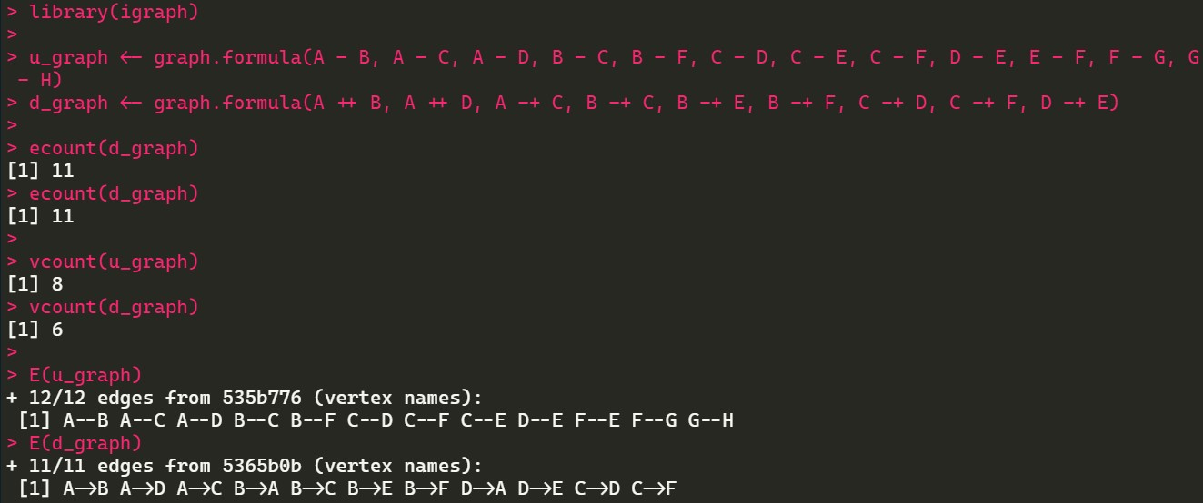**Output:**

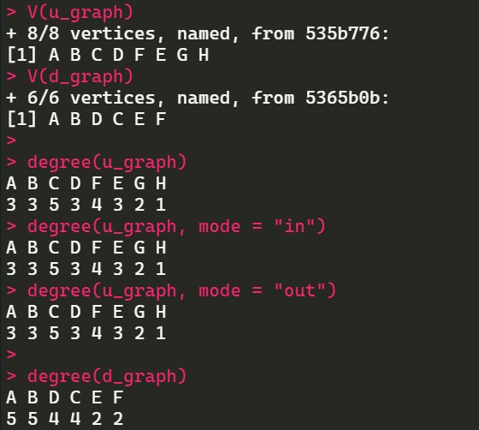

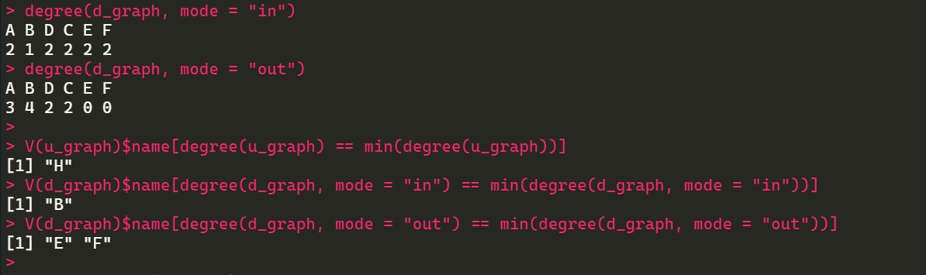

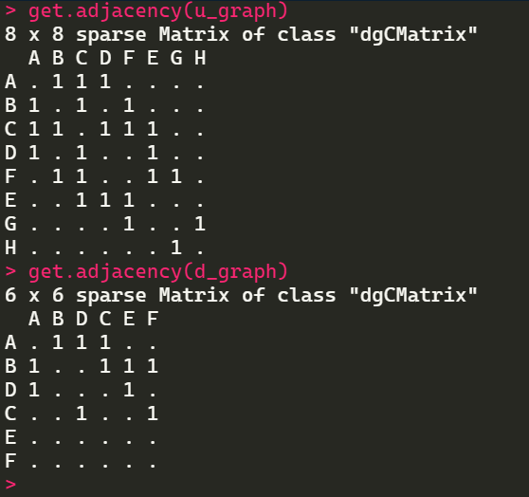

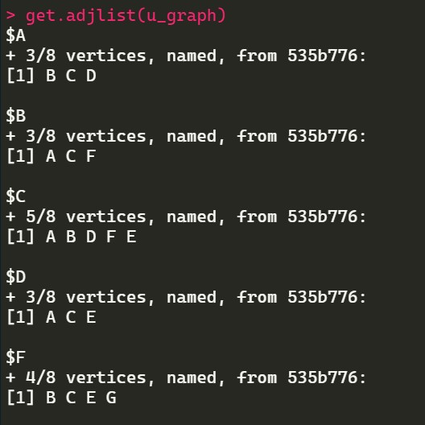

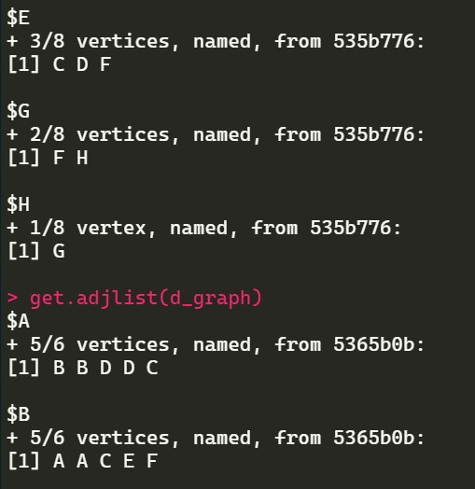

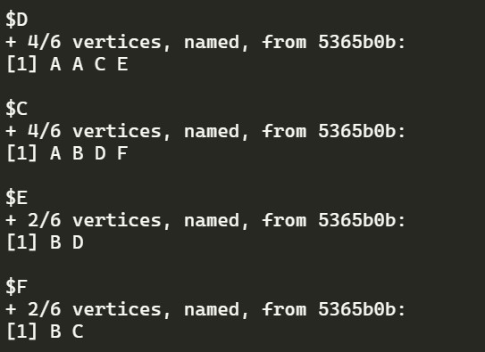

# Practical 2

**Aim:** Perform following tasks:

* View data collection forms and/or import onemode/two-mode datasets.
* Basic Networks matrices transformations.

**Software(s) used:**

* R ver. 4.1.3
* RStudio ver. 2022.02.0+433

## External packages required:

* igraph

## Description:

* + **The** igraph **package:** igraph is a library and R package for network analysis.

The main goals of the igraph library is to provide a set of data types and functions for:

* + - pain-free implementation of graph algorithms,
    - fast handling of large graphs, with millions of vertices and edges, allowing rapid prototyping via high level languages

like R.

* + getwd(): Used to get the absolute filepath of the current R session.
  + require(): library() and require() load and attach add- on packages.
  + read.csv(): Reads a file in table format and creates a data frame from it, with cases corresponding to lines and variables to fields in the file.
  + head(): Returns the first part of a vector, matrix, table, data frame or function. Since head() and tail() are generic functions, they may also have been extended to other classes.
  + graph.data.frame(): This function creates an igraph graph from one or two data frames containing the (symbolic) edge list and edge/vertex attributes.
  + get.adjacency(): Sometimes it is useful to work with a standard representation of a graph, like an adjacency matrix.
  + plot(): Draw a scatter plot with decorations such as axes and titles in the active graphics window.

## Source Code:

require("igraph")

edges - read.csv("C:/Temp/input_files/edges.csv") nodes - read.csv("C:/Temp/input_files/nodes.csv")

head(edges) head(nodes)

dir_graph - graph.data.frame(d = edges, vertices = nodes, directed = T)

get.adjacency(dir_graph) plot(dir_graph)

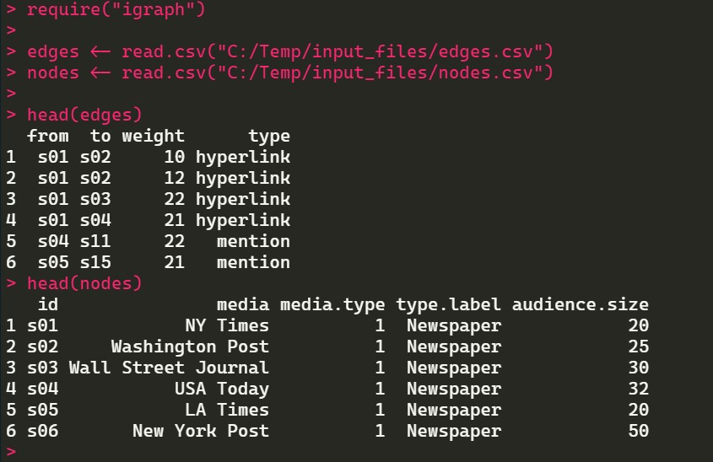**Output:**

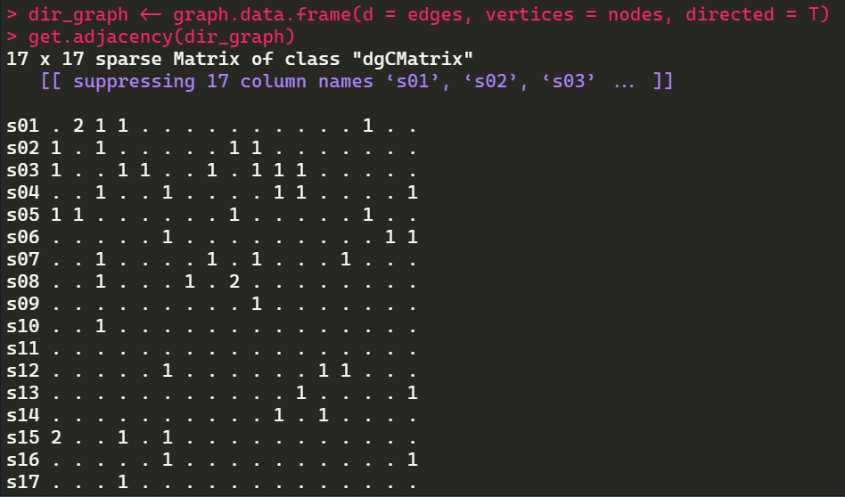

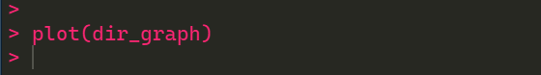

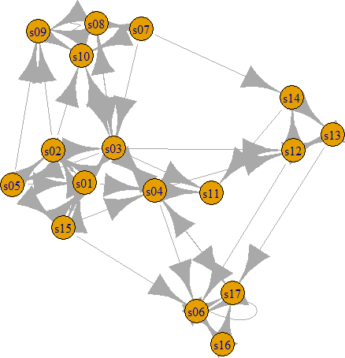

# Practical 3

**Aim:** Compute the following node level measures:

* Density
* Degree
* Reciprocity
* Transitivity
* Centralization
* Clustering.

**Software(s) used:**

* R ver. 4.1.3
* RStudio ver. 2022.02.0+433

## External packages required:

* igraph

## Description:

* + **The** igraph **package:** igraph is a library and R package for network analysis.

The main goals of the igraph library is to provide a set of data types and functions for:

* + - pain-free implementation of graph algorithms,
    - fast handling of large graphs, with millions of vertices and edges, allowing rapid prototyping via high level languages

like R.

* + library(): library() and require() load and attach add- on packages.
  + graph.famous(): Create an igraph graph from a list of edges, or a notable graph.
  + ecount(): Returns the count of number of edges in graph
  + vcount(): Returns the count of number of vertices in graph
  + graph.formula(): This function is useful if you want to create a small (named) graph quickly, it works for both directed and undirected graphs.
  + plot(): Draw a scatter plot with decorations such as axes and titles in the active graphics window.
  + reciprocity(): Calculates the reciprocity of a directed graph.
  + dyad.census(): Classify dyads in a directed graphs. The relationship between each pair of vertices is measured. It can be in three states: mutual, asymmetric or non-existent.
  + adjacent.triangles(): Count how many triangles a vertex is part of, in a graph, or just list the triangles of a graph.
  + transitivity(): Transitivity measures the probability that the adjacent vertices of a vertex are connected. This is sometimes also called the clustering coefficient.
  + degree(): The degree of a vertex is its most basic structural property, the number of its adjacent edges.
  + barabasi.game(): The BA-model is a very simple stochastic algorithm for building a graph.
  + watts.strogatz.game(): Generate a graph according to the Watts-Strogatz network model.
  + graph.union(): The union of two or more graphs are created. The graphs may have identical or overlapping vertex sets.
  + simplify(): Simple graphs are graphs which do not contain loop and multiple edges.

## Source Code:

library("igraph")

kite - graph.famous("Krackhardt_Kite") vcount(kite)

ecount(kite)

ecount(kite) / (vcount(kite) * (vcount(kite) - 1) / 2)

dir_graph - graph.formula(A + B, A + D, A -+ C, B -+ C, B -+ E, B -+ F, C -+ D, C -+ F, D -+ E)

plot(dir_graph) reciprocity(dir_graph) dyad.census(dir_graph)

mutual - dyad.census(dir_graph)$mut

mutual / (ecount(dir_graph))

atri - adjacent.triangles(kite) plot(kite, vertex.label = atri) transitivity(kite, type = "local")

adjacent.triangles(kite) / (degree(kite) * (degree(kite) - 1) / 2)

graph_2 - barabasi.game(50, p = 2, directed = F)

graph_1 - watts.strogatz.game(1, size = 100, nei = 5, p = 0.05)

graph - graph.union(graph_1, graph_2) graph - simplify(graph)

plot(graph)

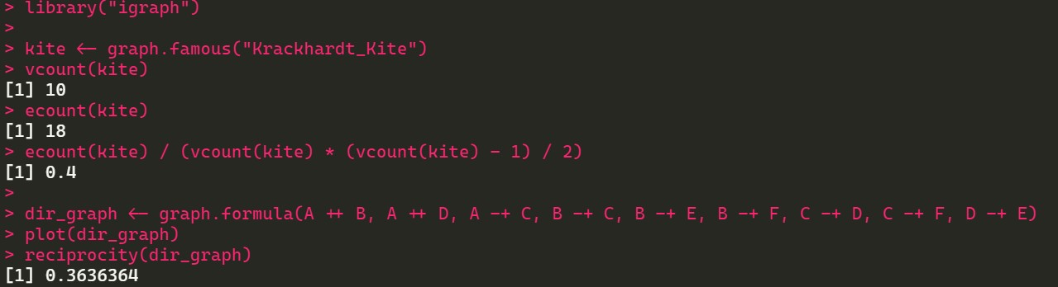**Output:**

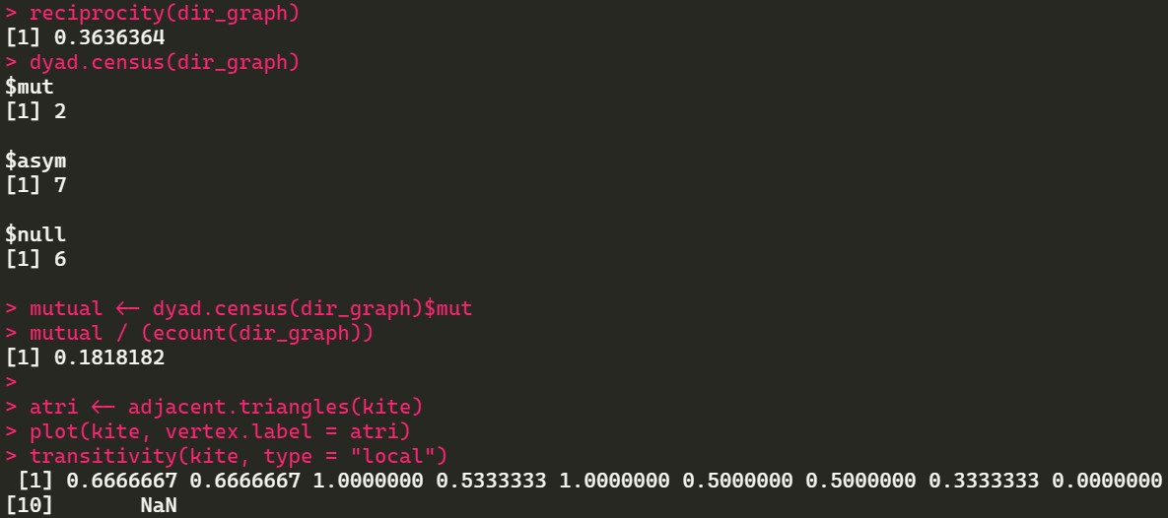

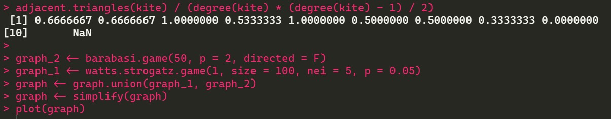

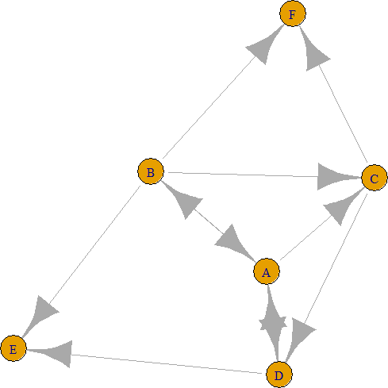

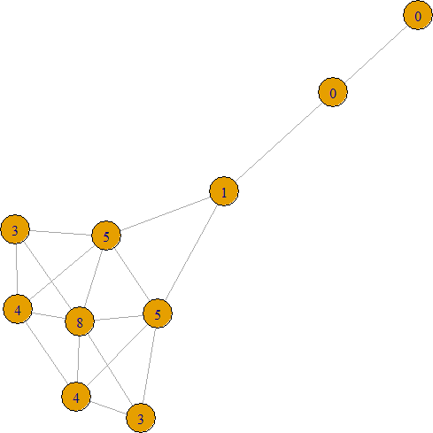

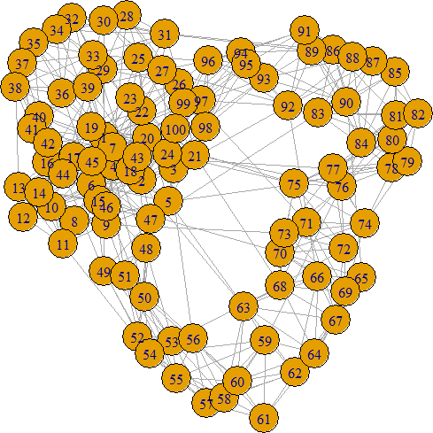

# Practical 4

**Aim:** For a given network find the following:

* Length of the shortest path from a given node to another node
* The density of the graph
* Draw egocentric network of node G with chosen configuration parameters.

**Software(s) used:**

* R ver. 4.1.3
* RStudio ver. 2022.02.0+433

## External packages required:

* igraph

## Description:

* + **The** igraph **package:** igraph is a library and R package for network analysis.

The main goals of the igraph library is to provide a set of data types and functions for:

* + - pain-free implementation of graph algorithms,
    - fast handling of large graphs, with millions of vertices and edges, allowing rapid prototyping via high level languages

like R.

* + library(): library() and require() load and attach add- on packages.
  + as.matrix(): matrix() creates a matrix from the given set of values. as.matrix() attempts to turn its argument into a matrix.
  + read.table(): Reads a file in table format and creates a data frame from it, with cases corresponding to lines and variables to fields in the file.
  + colnames() and rownames(): Retrieve or set the row or column names of a matrix-like object.
  + is.na(): The generic function is.na() indicates which elements are missing.
  + graph.adjacency(): graph_from_adjacency_matrix() is a flexible function for creating igraph graphs from adjacency matrices.
  + plot(): Draw a scatter plot with decorations such as axes and titles in the active graphics window.
  + shortest.paths(): shortest_paths() calculates one shortest path (the path itself, and not just its length) from or to the given vertex.
  + print(): print() prints its argument and returns it invisibly.
  + graph.formula(): This function is useful if you want to create a small (named) graph quickly, it works for both directed and undirected graphs.
  + graph.density(): The density of a graph is the ratio of the number of edges and the number of possible edges.
  + simplify(): Simple graphs are graphs which do not contain loop and multiple edges.

## Source Code:

library(igraph)

|  |  |  |  |  |  |
| --- | --- | --- | --- | --- | --- |
| matt - as.matrix(read.table(text= |  | | | | |
| "node R | S | T | U |  |  |
| R | 7 | 5 | 0 | 0 |  |
| S | 7 | 0 | 0 | 2 |  |
| T | 0 | 6 | 0 | 0 |  |
| U | 4 | 0 | 1 | 0", | header=T)) |
| nms - matt[, 1] |  |  | | | |
| matt - matt[, -1] |  |
| colnames(matt) - rownames(matt) - nms |  |
| matt[is.na(matt)] - 0 |  |
| g - graph.adjacency(matt,weighted=TRUE | ) |

plot(g)

s.paths - shortest.paths(g, algorithm = "dijkstra") print(s.paths)

shortest.paths(g, v="R", to="S") plot(g, edge.label=E(g)$weight)

dg - graph.formula(1-+2, 1-+3, 2 +3) plot(dg)

graph.density(dg, loops=TRUE) graph.density(simplify(dg), loops=FALSE)

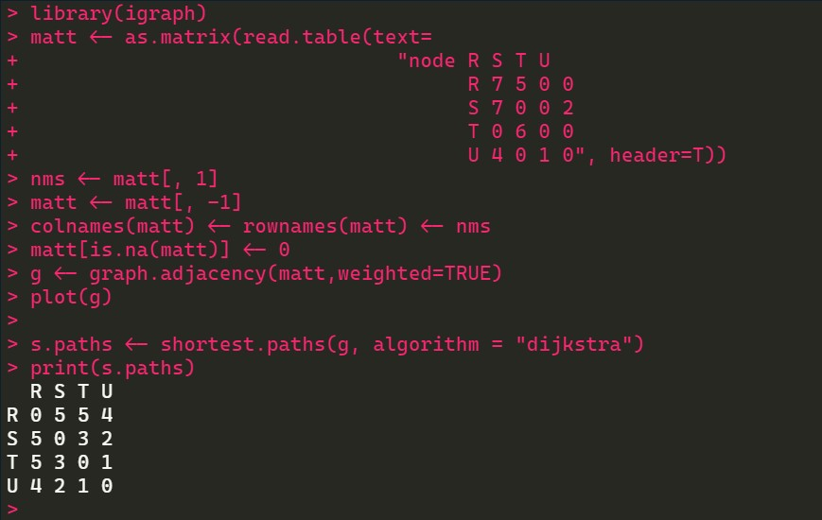**Output:**

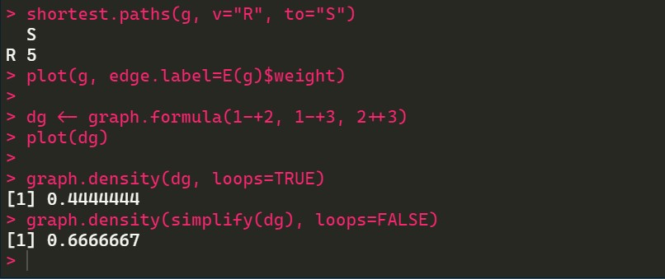

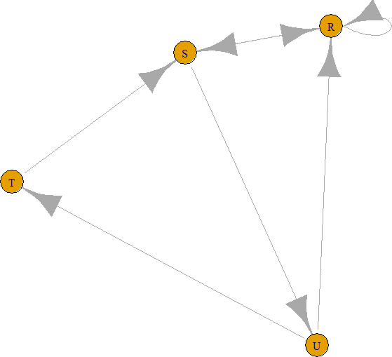

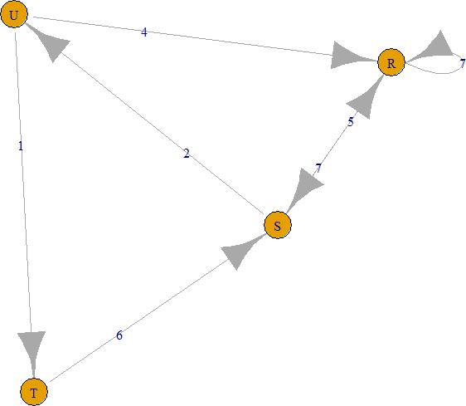

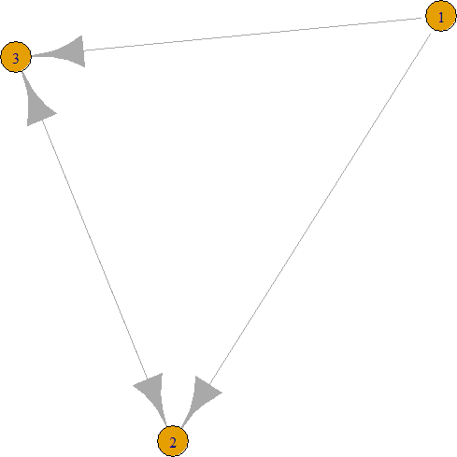

# Practical 5

**Aim:** Write a program to distinguish between a network as a matrix, a network as an edge list and a network as a sociogram (or “network graph”) using 3 distinct networks representatives of each.

**Software(s) used:**

* R ver. 4.1.3
* RStudio ver. 2022.02.0+433

## External packages required:

* igraph

## Description:

* + **The** igraph **package:** igraph is a library and R package for network analysis.

The main goals of the igraph library is to provide a set of data types and functions for:

* + - pain-free implementation of graph algorithms,
    - fast handling of large graphs, with millions of vertices and edges, allowing rapid prototyping via high level languages

like R.

* + library(): library() and require() load and attach add- on packages.
  + graph.formula(): This function is useful if you want to create a small (named) graph quickly, it works for both directed and undirected graphs.
  + plot(): Draw a scatter plot with decorations such as axes and titles in the active graphics window.
  + get.adjacency(): Sometimes it is useful to work with a standard representation of a graph, like an adjacency matrix.
  + E(): An edge sequence is a vector containing numeric edge ids, with a special class attribute that allows custom operations:

selecting subsets of edges based on attributes, or graph structure, creating the intersection, union of edges, etc.

* + get.adjedgelist(): Create adjacency lists from a graph, either for adjacent edges or for neighboring vertices.

## Source Code:

library(igraph)

sociogram - graph.formula(Andy +Garth,Garth-+Bill,Bill-

+Elena,Elena +Frank,Carol-

+Andy,Carol-+Elena,Carol+

+Dan,Carol +Bill,Dan +Andy, Dan +Bill)

plot(sociogram)

get.adjacency(sociogram) E(sociogram) get.adjedgelist(sociogram)

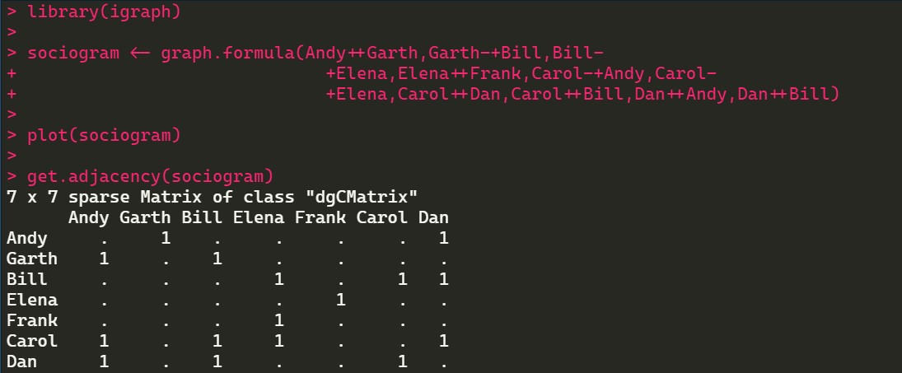**Output:**

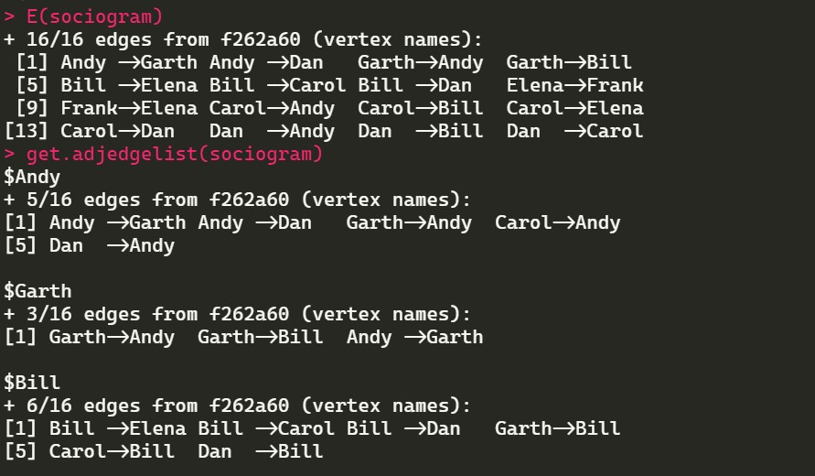

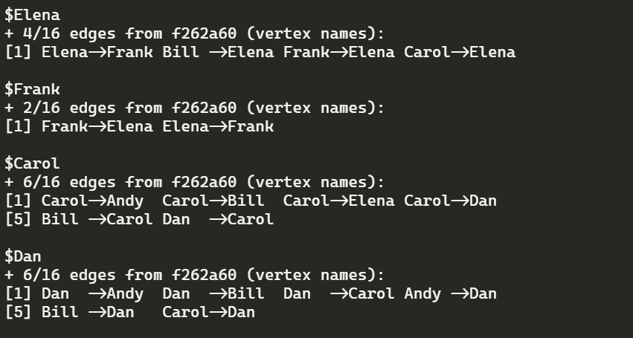

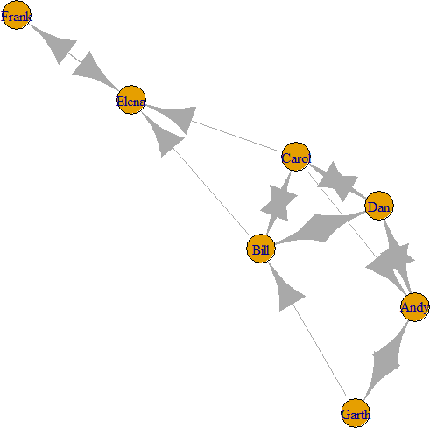

# Practical 6

**Aim:** Write a program to exhibit structural equivalence, automatic equivalence, and regular equivalence from a network.

**Software(s) used:**

* R ver. 4.1.3
* RStudio ver. 2022.02.0+433

## External packages required:

* igraph
* sna

## Description:

* + **The** igraph **package:** igraph is a library and R package for network analysis.

The main goals of the igraph library is to provide a set of data types and functions for:

* + - pain-free implementation of graph algorithms,
    - fast handling of large graphs, with millions of vertices and edges, allowing rapid prototyping via high level languages

like R.

* + **The** sna **package**: sna is a package containing a range of tools for social network analysis. Supported functionality includes

node and graph-level indices, structural distance and covariance methods, structural equivalence detection, p* modeling, random graph generation, and 2D/3D network visualization (among other things).

* + library(): library() and require() load and attach add- on packages.
  + read.csv(): Reads a file in table format and creates a data frame from it, with cases corresponding to lines and variables to fields in the file.
  + equiv.clust(): equiv.clust() uses a definition of approximate equivalence (equiv.fun()) to form a hierarchical clustering of network positions.
  + plot(): Draw a scatter plot with decorations such as axes and titles in the active graphics window.
  + sedist(): sedist() uses the graphs indicated by g in the arguments to assess the extent to which each vertex is structurally equivalent.
  + cmdscale(): Classical multidimensional scaling (MDS) of a data matrix.
  + as.dist(): This function computes and returns the distance matrix computed by using the specified distance measure to compute the distances between the rows of a data matrix.
  + blockmodel(): Given a set of equivalence classes and one or more graphs, blockmodel will form a blockmodel of the input graph(s) based on the classes in question

## Source Code:

library(sna) library(igraph)

links2 - read.csv("C:/Temp/input_files/edges1.csv", header=T, row.names=1)

eq -equiv.clust(links2) plot(eq)

g.se -sedist(links2)

plot(cmdscale(as.dist(g.se))) b -blockmodel(links2,eq,h=10) plot(b)

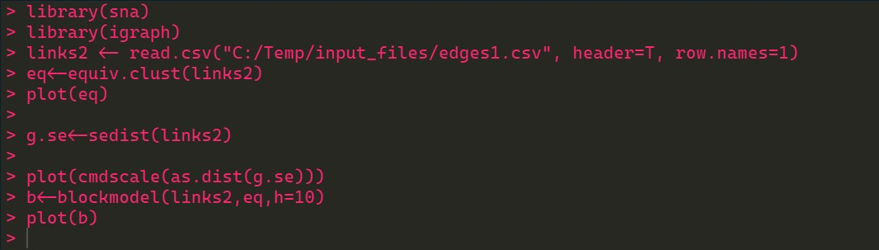**Output:**

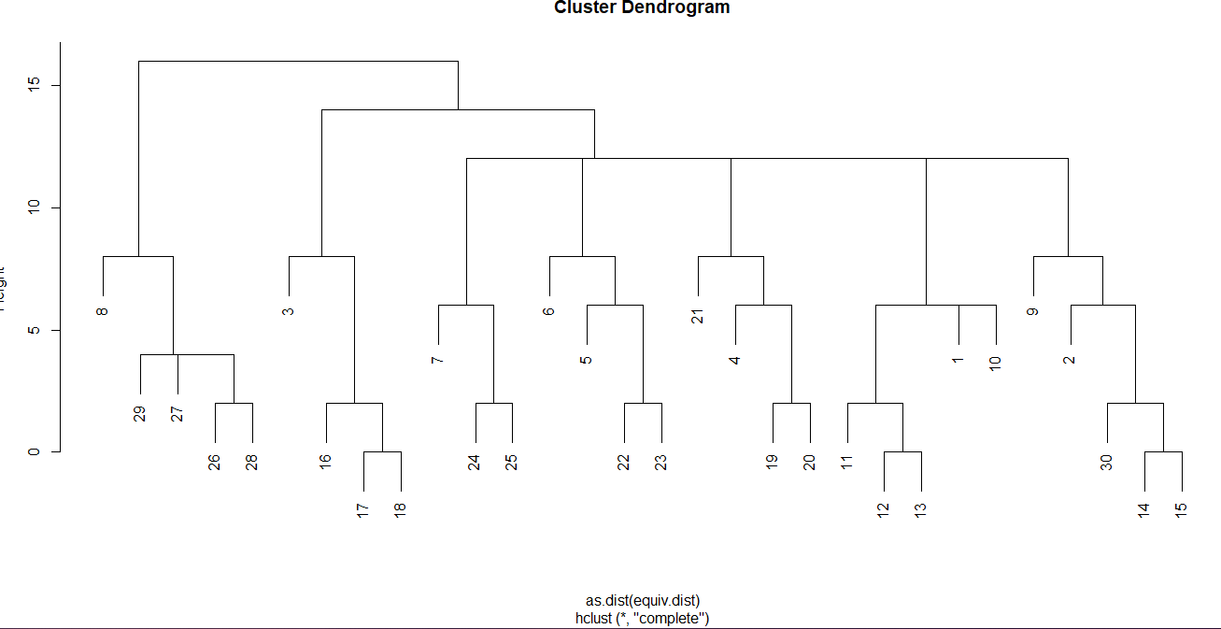

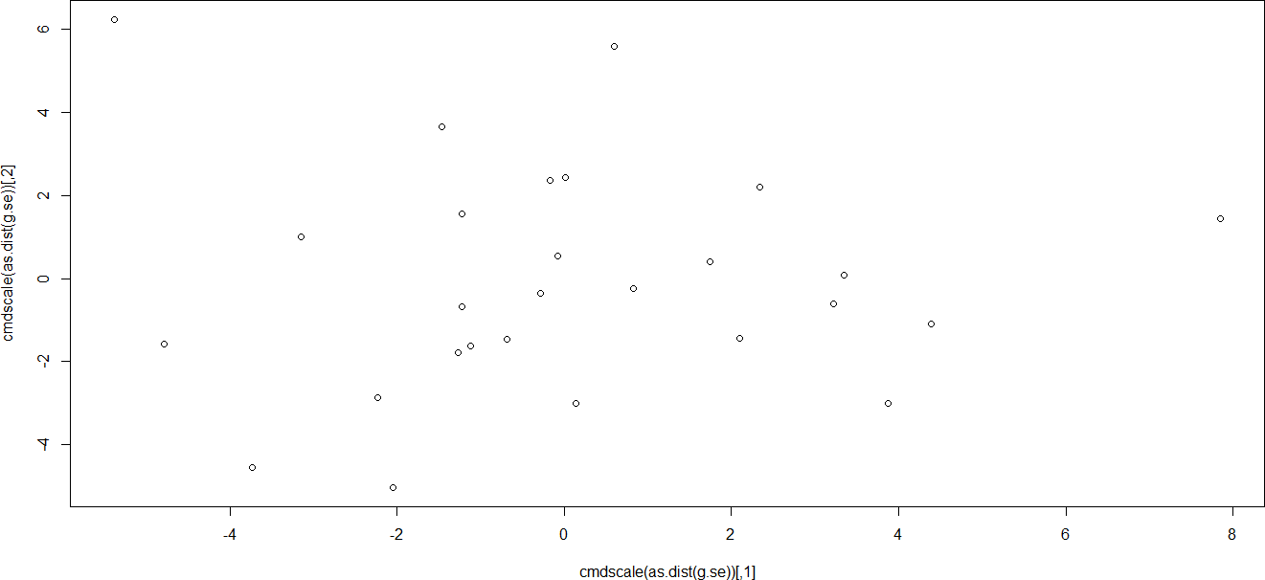

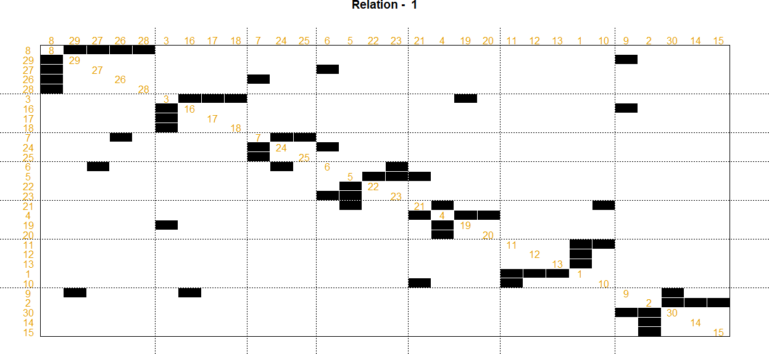

# Practical 7

**Aim:** Perform SVD analysis of a network.

**Software(s) used:**

* R ver. 4.1.3
* RStudio ver. 2022.02.0+433

## External packages required:

* igraph

## Description:

* + **The** igraph **package:** igraph is a library and R package for network analysis.

The main goals of the igraph library is to provide a set of data types and functions for:

* + - pain-free implementation of graph algorithms,
    - fast handling of large graphs, with millions of vertices and edges, allowing rapid prototyping via high level languages

like R.

* + matrix(): matrix() creates a matrix from the given set of values.
  + c(): Combines values into a vector or list.
  + print(): print() prints its argument and returns it invisibly.
  + svd(): Compute the singular-value decomposition of a rectangular matrix.

## Source Code:

library(igraph)

a - matrix(c(1, 1, 1, 1, 1, 1, 1, 1, 1, 1, 1, 1, 0, 0, 0, 0,

0, 0, 0, 0, 0, 1, 1, 1, 0, 0, 0, 0, 0, 0, 0, 0, 0, 1, 1,

1), 9, 4)

print(a) svd(a)

## Output:

